Which Compost Method is Most Conducive to Sustainable Development?
  - Comparative Analysis – Manual vs Automated Compost System

Adams, James, Alavez, Mario, Dennes, Christina, & Guerrero, Lisandra

Abstract
The primary experiment will perform a comparative analysis between a manual and automated compost system. The manually operated compost system serves as a dependent control variable. The independent variable is an automated compost system using an electric motor. Both variables are used to determine which is the most sustainable compost method. The independent variables are powered by solar energy whereas, the manually operated system is human-operated. From manufacturing to operations, all materials are measured by their anthropogenic emission output to determine the environmental impact. Whereas, the economic impact is estimated by the costs and savings. The productivity and efficiency between human-operated and automated compost systems determine the social impact. The purpose and result of this experiment will evaluate which variable is most sustainable. The secondary experiment will measure the number of microorganisms present when composting.

Contents
Abstract 0
Literature Review 2
What is Compost? 2
Where is Compost Used? 3
What is the defined goal sustainable development? 3
Background 3
Hypothesis 3
Assumption 4
Experiment Methodology 4
Microbial Life 4
Experiment Results 6
Dependent vs Independent Results 6
Dependent Variable Results – Manually Operated 6
Independent Variable Results – Automated 8
Sustainable Development Impact 10
Economic Impact 10
Environmental Impact 10
Social Impact 11
Conclusion 11
Future Work 11
Works Cited 12
Reference Sources 12

Literature Review

What is Compost?
Compost is organic matter created through the act of composting organic waste such as food scraps, tree clippings, and manure combined into a proper ratio creates compost. Air, water, carbon, nitrogen, and microorganisms are some of the main ingredients found throughout the composting process. Some familiar with the process of composting suggest all ingredients must be present. However, compost can still be formed at a slower rate with the absence of an element.
Composting occurs in two ways: aerobic and anaerobic decomposition. Aerobic composting is defined by the usage of carbon, oxygen, nitrogen, and water. Anaerobic composting defined by the absence of oxygen with carbon, nitrogen, and water present. A difference in decomposition method determines the microorganism’s presence. Aerobic composting possesses the airbreathing microbial life which helps increase the temperature of compost as they break down materials and release odorless gas (Smith, 2009). Anaerobic composting possesses non-air breathing microbial life that releases odorless toxic gas during the breakdown process.
A control on temperature, moisture, and oxygen accelerate the decomposition process. Turning or mixing the compost pile will aerate the organic matter and provide enough oxygen for the air-breathing microorganisms. According to the Texas AgriLife Extension, the oxygen level of compost should be kept at a minimum of five percent to help with the decomposition process.
Microorganisms require water to stay alive and is critical for a healthy compost system, however, the balance of water is paramount. Too much water can cause the compost pile to become mushy and smelly as the anaerobic microbes take over (Smith, 2009). The rotation of a compost pile helps dry the compost. It is recommended to aim for a moisture content of forty-five to fifty percent (Smith, 2009).
Microbial life correlates to the temperature of the compost. The microorganisms initiate the decomposition process by consuming the organic material as a food source while heat releases. The temperature of the organic material determines which microorganisms are present. Psychrophilic organisms can be found in vast quantities early in the composting process when temperatures are between zero to sixty-five degrees Celsius. When the temperature increases to around seventy to ninety degrees Celsius Mesophilic organisms are discovered. Thermophilic organisms are found when temperatures exceed one-hundred degrees Celsius (Smith, 2009).

Where is Compost Used?
After the composting process is complete, the compost can be utilized anywhere in a garden. Compost adds beneficial microbes to the soil that help supply key nutrients to plant roots (Smith, 2009). Compost also aids by retaining water and suppressing weeds. Once the compost is ready to be used, it is recommended to apply it after it has rained or after watering the area of use (Smith, 2009).
Compost is recognized as a valuable fertilizer made from the use of organic waste. Based on current methods, the food waste found in landfills will increase with the global population and consequently so will the production of methane which is estimated to be thirty-four times more powerful than carbon dioxide. The methods involved with composting can convert organic material into fertilizer which can aid in carbon sequestration.

What is the defined goal sustainable development?
"Sustainable development targets three broad goals for society: economic development, social inclusion, and environmental sustainability (Sachs 219)." With this in mind, we reflect on the sustainability triangle, and work towards a balance/harmony between the three areas in consideration. At times, different areas may complement each other, but they may also seem to be conflict at other times. It is up to the developer(s) to give a fair amount of time to each area before making final decisions, and/or moving forward on any sustainable development project.

Background

Hypothesis
The primary hypothesis is which composting method is more sustainable in the aspect of economic, environmental, and social impacts. However, the social impact can only be measured based on the value an individual or group places. For instance, do you value productivity and efficiency over physical activity and time in nature or outside? The secondary hypothesis is that there will be more microbial life present in the later stages of the composting process rather than earlier stages.

Assumption
Our assumption prior to conducting this research is that the manually operated compost system will score a higher economic, environmental, and social impact rating. Whereas, the manually operated system will be the preferred, most sustainable method. One could consider that modern methods might increase productivity and efficiency but at the cost of emitting higher amounts of anthropogenic emissions. Based on this notion, the independent variable that utilizes an electric motor will score a lower rating. Our research findings will determine which composting method is more sustainable.
Our secondary assumption is that there will be more microorganisms present in the later stages of the composting process due to the heat the compost emits.

Experiment Methodology

Microbial Life
Microorganisms play a critical role in the composting process. The heat produced in the organic material breakdown from the heat expunged by the microbes. The temperature of the compost will determine the type of microbial life found. Psychrophilic organisms tend to flourish at the beginning of the composting process when temperatures are between zero to sixty-five degrees Celsius. Temperatures of seventy to ninety degree Celsius will have mesophilic organisms. Thermophilic organisms are more predominant in temperatures that exceed one-hundred degrees Celsius.
A theory was established to better understand the different microorganisms present in compost. We predict more microorganisms are present in the later rather than early stages of the composting process. To test this theory, we went to a local urban farm, Finca Tres Robles.
The farm has six outdoor compost piles divided between a metal sheet that is exposed to environmental factors (See Figure 2). It takes twelve weeks to complete the composting process whereas each compost pile rests in its divided section for two weeks. We measured the temperature of the six compost piles at the urban farm and collected samples to test in a lab (see table 1).
Week | Temperature (Celsius)
Two | 60
Four | 55
Six | 50
Eight | 50
Ten | 52
Twelve | 55
The two samples collected [from week four and twelve] were taken back to UHD to undergo a drop plate method to isolate and grow various colonies. We diluted the two samples prior to initiating the drop plate method and placed them into five test tubes were used for the dilution process. The tubes were labeled from A to E and had two milliliters of water.
Table 1: The six samples collected from the farm and the temperature.

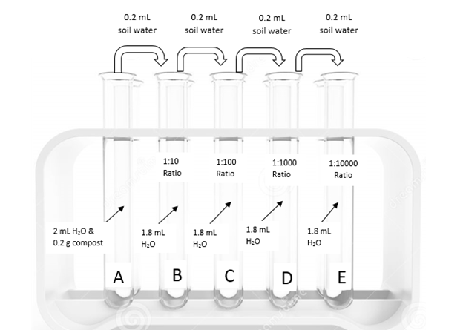
0.2 g of compost was weighed from week four and transferred into test tube labeled A. 0.2 mL of test tube A's solution was transferred into test tube B with a result of a 1:10 ratio. This process was repeated for test tube C (1:100), tube D (1:1000), and tube E (1:10000). The sample for week twelve followed the same process.
Figure 1: Test Tubes A - E

Three drops of twenty uL were placed on a plate for week four's sample A. The plate containing the sample was tilted forward for the three drops to run down the plate [crossing the length of the plate but without crossing rows or reaching the end of the plate] until the point where the sample reached but did not touch the opposite side of the plate. Afterward, the plate was sealed and left untouched for colonies to grow. This process was repeated for week four and twelve test tube B through E.
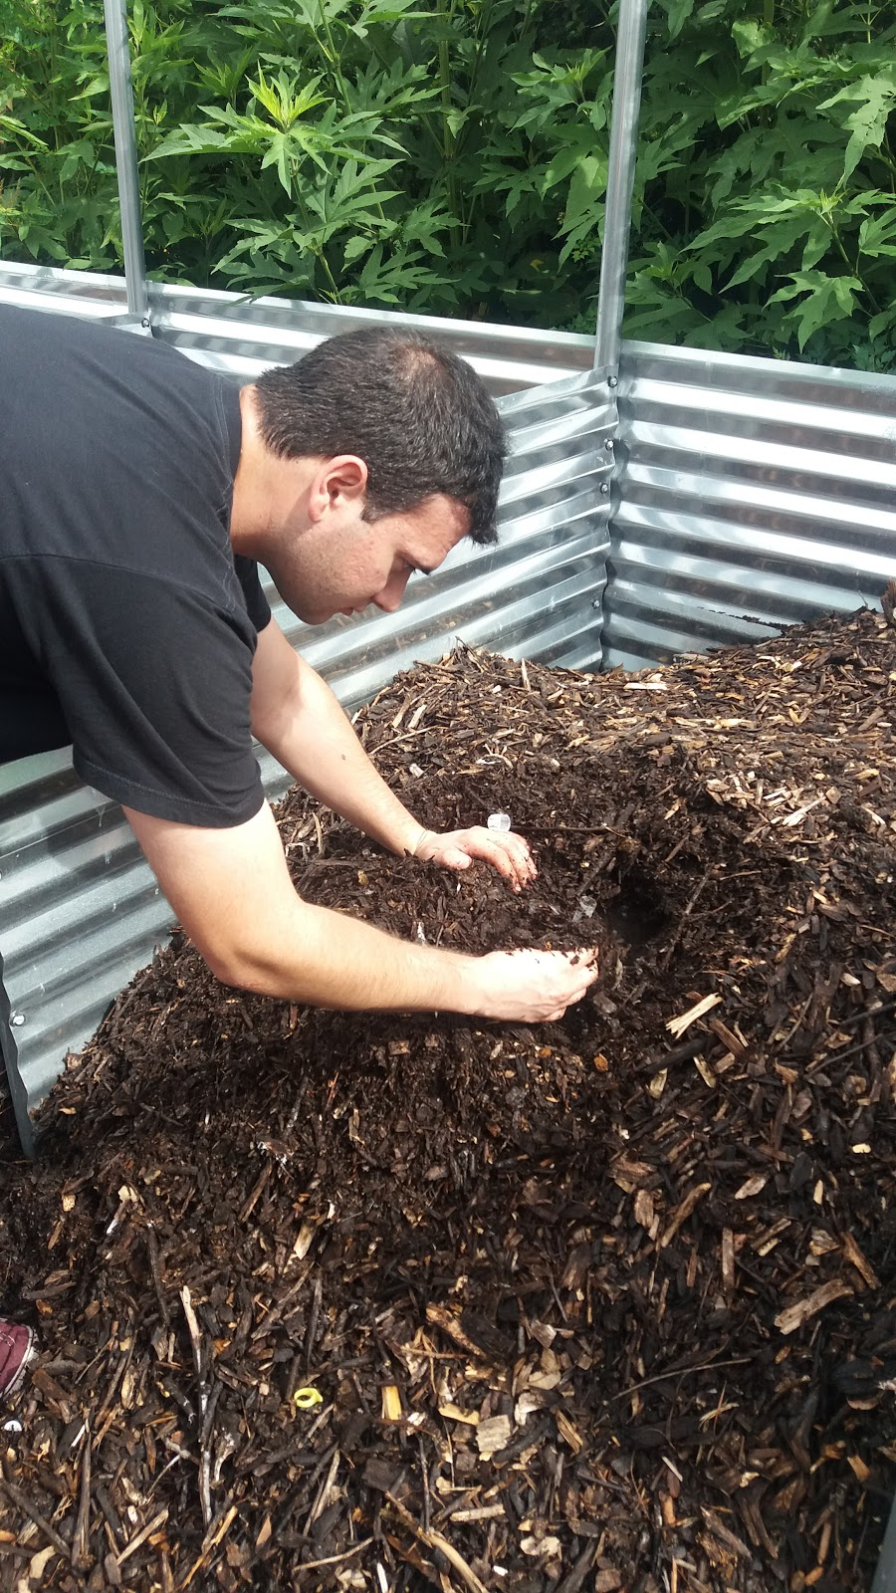
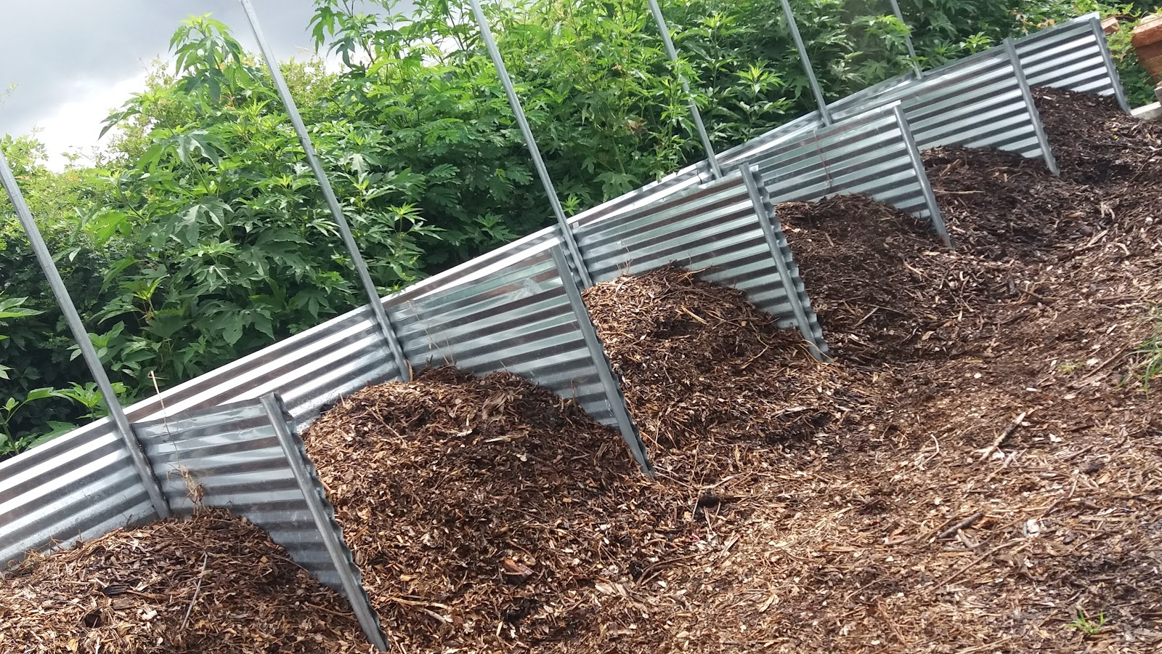
The samples were sent to University of Houston - Clear Lake campus after a week of bacterial growth. Of the samples, eight plates were used. From each plate, two sets of four streaks were created. The purpose of streaking was to identify eight different colonies. An inoculation needle was used to streak for each colony in its corresponding section of the plate. These samples were left at UHCL for a week to undergo a bacteria identification, maldi tof.
Figure 3: A composting sample collected from week 4

Figure 2: Six Composting Piles in Finca Tres Robles

Experiment Results

Dependent vs Independent Results

Dependent Variable Results – Manually Operated
Fully operated human compost system

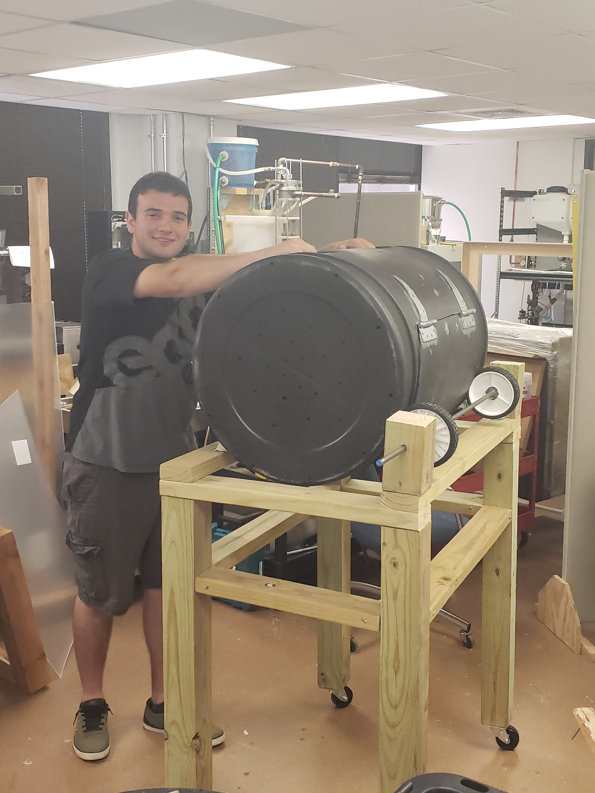
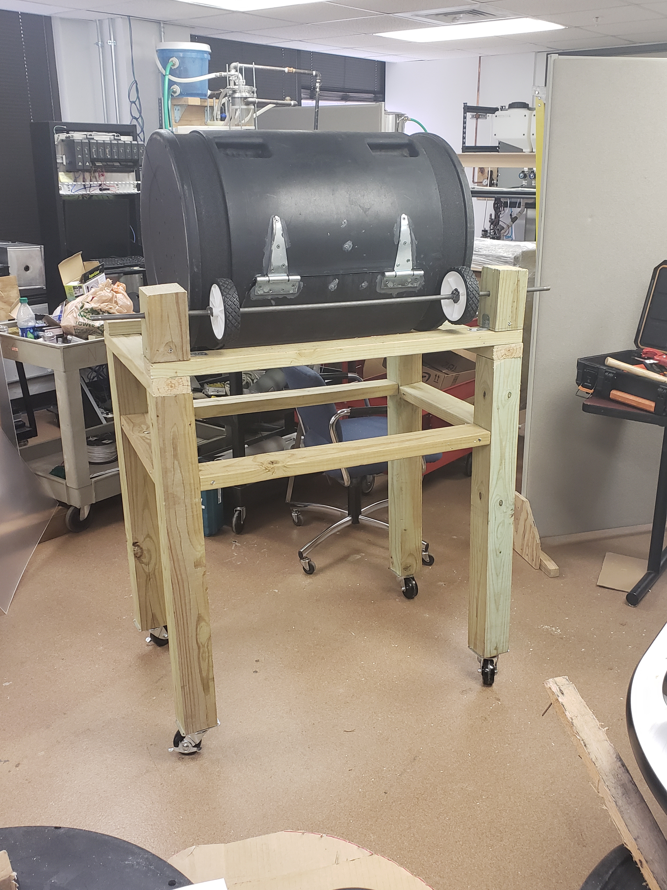
The source used for a dependent controlled variable is a manual operated compost system. This variable is restricted to human operation. Calculations factored range from the manufacturing to distribution methods.
Figure 5: Manual Compost
Figure 4: Christian with Manual Compost

Sustainable Impact

Economic Impact
Item | Quantity | Price | Total Cost
Compost Wizard Jr | 1 | $99.99 | $99.99
Compost Frame | X | x | X
Food Waste | x | x | x
Cardboard | x | x | X
Wheels (6) | 2+4 | $9.98+$7.96 | $51.77
Screws | 24 | $0.28 | $6.69
Glue | 1 | $6.69 | $6.99
Grip Tape | 1 | $25.99 | $25.99
Total |  | $150.89 | $191.43

Environmental Impact
Table 2: Economic Impact
Item | Material | Weight | Emission
Compost Wizard Jr. | 100% Recycled Polyethylene | 12 lb | 24.8 kg CO_{2e}
Compost Frame | Lumber | 30 lb | 2.6 kg CO₂
Food Waste | Food Scraps | 100 lb p/month | 86.18 kg CO₂
Cardboard | Paper / Wood | 60 lb p/month | 27.22 kg CO₂
Wheels (6) | Stainless Steel / Rubber | 2 lb | 5.1 kg CO₂
Screws | Steel | 1 lb | 1.8 kg CO₂
Glue | Plastic | 0.25 lb | 0.1 kg CO₂
Grip Tape | Rubber | 0.28 lb | 0.2 kg CO₂
Total |  | 205.53 lb | 148 kg CO₂

Social Impact
Table 3: Environmental Impact
Usage | Time | Use P/Day | Total Time P/Day[week]
Manual | 1 hr [20 min] | 3x[1x] | 3[1] hrs

Independent Variable Results – Automated
Table 4: Social Impact
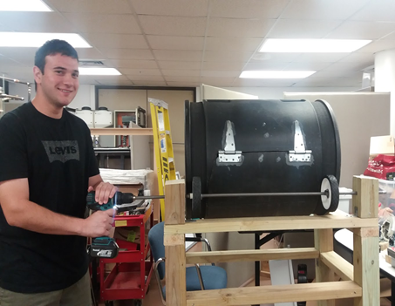
Partially operated human compost system utilizing an electric motor to rotate the wheel
Figure 6: Automated Compost
Functions through the usage of an electric motor. Calculations range from the manufacturing to distribution methods. All calculations are based on the development and testing of resources used to conduct this experiment.

Sustainable Impact

Economic Impact
Item | Quantity | Price | Total Cost
Compost Wizard Jr | 1 | $99.99 | $99.99
Compost Frame | X | x | x
Food Waste | x | x | X
Cardboard | X | X | x
Wheels | 2+4 | $9.98+$7.96 | $51.77
Screws | 24 | $0.28 | $6.69
Glue | 1 | $6.99 | $6.99
Grip Tape | 1 | $25.99 | $25.99
Motor | 1 | $45.00 | $45.00
Total |  | $196.19 | $236.43

Environmental Impact
Table 5: Economic Impact
Item | Material | Weight | Emission
Compost Wizard Jr. | 100% Recycled Polyethylene | 12 lb | 24.8 kg CO₂E
Compost Frame | Lumber | 30 lb | 2.6 kg CO₂
Food Waste | Food Scraps | 100 lb p/month | 86.18 kg CO₂
Cardboard | Paper / Wood | 60 lb p/month | 27.22 kg CO₂
Wheels (6) | Stainless Steel / Rubber | 2 lb | 5.1 kg CO₂
Screws | Steel | 1 lb | 1.8 kg CO₂
Glue | Plastic | 0.25 lb | 0.1 kg CO₂
Grip Tape | Rubber | 0.28 lb | 0.2 kg CO₂
Motor | Steel/ Copper Wire | 2 lb | 8.61 kg CO₂
Total |  | 207.53 lb | 156.61 kg CO₂

Social Impact
Table 6: Environmental Impact
Usage | Time | Use P/Day | Total Time P/Day
Automated | 30 min | 3x | 1.5 hrs
Table 7: Social Impact

Sustainable Development Impact
Displayed below are the result totals from the experiment results between our dependent and independent variables. The dependent variable being the manual compost system and the independent variable being the automated compost system.
Impact | Dependent Variable  Manual | Independent Variable  Automated
Economic | $ | $$
Environmental | X | XX
Social
Sustainable | $X | $$XX
Table 8: Sustainable Impact

Economic Impact
The dependent variable is less expensive to develop and operate. For example: say an average college student's time is worth $7 per hour. This is one of the many favors related to a manual or automated system. However, a manual system costs are directly linked to the development of the compost system.
Whereas, the independent variable is more expensive to develop and operate. An automated system costs are linked to the development and daily operations to run the system. It requires a motor that needs to be purchased and operate through an electric current. Coal electricity would be the cheapest and dirtiest whereas solar or wind will be cleaner and more expensive.

Environmental Impact
The dependent variable provides a higher positive environment impact. The manual operated system uses less resources and emissions to develop a compost system.
Whereas, the independent variable displayed the lowest negative impact. The automated system uses a motor which if run on coal would contribute to higher anthropogenic emissions. Moreover, the materials used to create the motor result in higher anthropogenic emissions released in our atmosphere.

Social Impact
The dependent variable provided the highest positive social impact. However, the manual operated system does not increase productivity and efficiency. It requires more hours per day to operate but increases the time an operator would be physically active or in nature.
Whereas, the independent variable displayed the lowest negative impact. The automated system increases productivity and efficiency by half the time in comparison to a manual operated system. However, the operator’s physical activity or time in nature is decreased.

Conclusion
The economic and environmental impact points in the favor of a manually operated compost system. However, the social impact shares a few discrepancy’s. Point being, the value between productivity and efficiency or physical activity and time in nature. If the owner or operator aims to be more productive or efficient then the automated system is the best choice. But, if the owner or operator deems more value toward human activity and time in nature then the manual system is the best choice.

Future Work
- It has come to be known that many forms of plastic can be labeled as harmful for humans to ingest. Most notably when packaged with water and exposed to heat or sunlight. The assumption that needs an answer is if storing waste in plastic compost containers is harmful for humans or other carbon-based life forms. Moreover, what material is best to use for a compost system. If the material is deemed harmful then how does the transfer of compost to a garden bed impact the crop nutrients. Based on experiments findings, the research will determine the best sustainable practices to mitigate risk.
- Discover the precise measurements and carbon footprint of a vertical axis wind turbine that will power the rotation of a compost storage container. Through this discovery, implement a vertical axis wind turbine to the compost system based on research findings in this report.
- Research the hypothesis, when will the manual and automated compost system reach a level of net zero? By incorporating the financial, environmental, and social factors will determine when a system will reach net zero.

Works Cited
Sachs, Jeffrey D. The Age of Sustainable Development. New York, Chichester, West Sussex: Columbia University Press, 2015.
Smith, K. "How to Build, Maintain, & Use a Compost System." Introduction: Why Compost? (2009): 11-14. EBSCO Host.

Reference Sources
- Calculator for food and cardboard CO² saving
  - http://www.stopwaste.co/calculator/
- Calculate CO²
  - https://timeforchange.org/plastic-bags-and-plastic-bottles-CO2-emissions (plastic)
  - http://bioage.typepad.com/greencarcongress/docs/lehighghg.pdf (EPDM)
  - http://www.co2list.org/files/carbon.htm (carbon calculation)
  - http://www.winnipeg.ca/finance/findata/matmgt/documents/2012/682-2012/682-2012_Appendix_H-WSTP_South_End_Plant_Process_Selection_Report/Appendix%207.pdf (aluminum)
  - http://bioage.typepad.com/greencarcongress/docs/lehighghg.pdf (rubber)
  - Smith, Kelly. How To Build, Maintain & Use a Compost System: Secrets & Techniques You Need to Know to Grow the Best Vegetables. 2009, p171-188. 18p.
  - https://watchmywaste.com.au/food-waste-greenhouse-gas-calculator/ (Food scrap)

